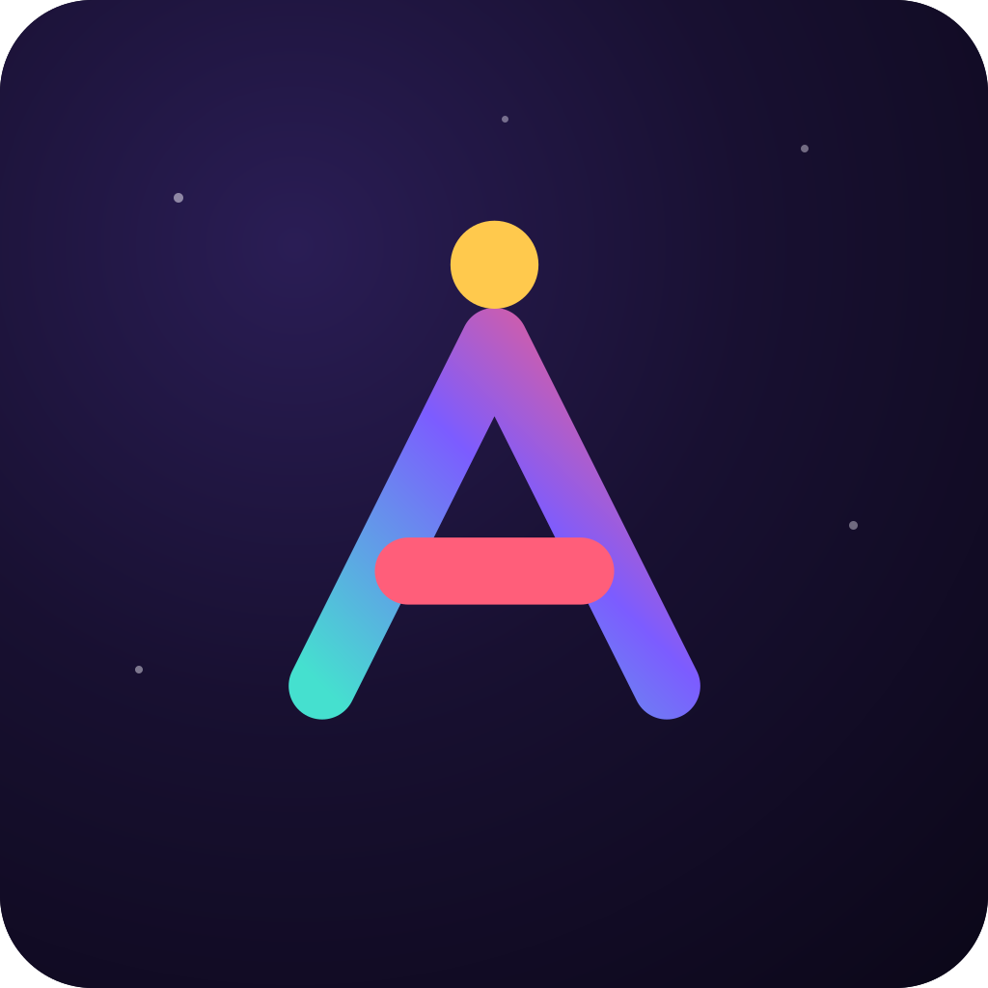 AbleMakers
FACILITATOR PACK
Your first AbleMakers AI workshop
A calm, ready-to-run session for learners with intellectual and developmental disabilities.
30 minutes | 1-3 learners per device | Browser + optional sound
Learners finish one scripted practice quest, learn one safety rule, and stay in charge. No learner account, no cost, and no live AI replies.

Before learners arrive
[ ] Open ablemakers.org/start on each device and test the sound.
[ ] Choose Start for a new learner on any reused or shared device.
[ ] Offer bigger text, headphones, read-aloud, and the learner's usual communication support.
[ ] Say that this is safe practice. Nothing can go wrong by tapping.
[ ] Keep names, addresses, passwords, money details, and ID numbers out of any real AI chat.

The 30-minute run sheet
0-5 Welcome and get comfortable
Let each learner choose text size and sound. Say: Today, you are in charge of an AI helper.
5-20 Learners drive
Point to the glowing message, then wait. Let the learner tap, listen, pause, or ask for a break.
20-25 Practice the safety rule
Ask: What stays private? Repeat: private things stay private, and people help with big choices.
25-30 Celebrate and choose
Name one thing the learner did. See the badge. Offer another activity only if the learner wants more.
EASY READ LEARNER PAGE
What will happen today?
A visual schedule. Point to each step as you go.
1. Get comfortable
Choose bigger words, sound, headphones, or no headphones.
2. Meet the helper
This is practice. A live AI is not talking to you here.
3. You drive
You choose and tap the glowing messages. Your helper can wait.
4. Practice safety
Keep private things private. Ask a person before a big choice.
5. Celebrate
See your badge. Choose another activity or finish for today.

My choices
I can point, speak, sign, use AAC, or show one of these choices:
[ ] Stop
[ ] Take a break
[ ] Read it to me
[ ] Make the words bigger
[ ] Help me
Words you can use
"You are the driver. I can point or read with you, but you get to tap. If you want a break, say stop."
EASY READ SAFETY HANDOUT
Four rules for using AI safely
Read together. Keep this page near the device.
1. Private stays private
Do not share your address, phone number, password, money details, or ID number.
2. AI can be wrong
Check surprising answers. Ask again or ask a person you trust.
3. Spot trick signs
Hurry. Secret. Money. Password. Stop when a message uses these signs.
4. People help with big choices
Ask a trusted person about medicine, money, paying, signing, safety, or big feelings.
If something went wrong
Stop. Tell a person you trust. Get help changing a password or checking an account. You are not in trouble for asking for help.
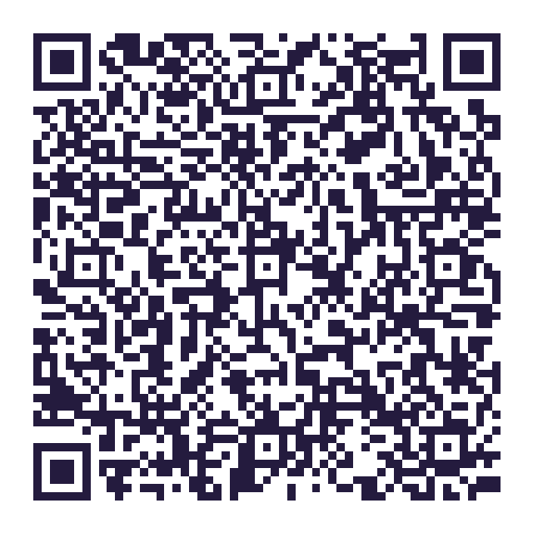
Practice safely: ablemakers.org/start
Scripted practice. No learner account. No live AI reply.
KEEP WITH THE LEARNER OR PROGRAM
Facilitator observation sheet
Mark what happened in this session. This is not a test or validated assessment.
Learner code (not a name): __________________ Date: __________________
What happened | No prompt | One prompt | Helped | Not tried
The learner chose and sent one message. | [ ] | [ ] | [ ] | [ ]
The learner named one thing that stays private. | [ ] | [ ] | [ ] | [ ]
The learner identified when to ask a trusted person. | [ ] | [ ] | [ ] | [ ]

What the support levels mean
No prompt: The learner did it without a cue after the activity began.
One prompt: One spoken, pictured, or pointed reminder helped.
Helped: The learner used more than one prompt or shared the action.
Not tried: The group did not reach it, or the learner declined or took a break.
Privacy boundary
Keep this individual sheet with your learner or program. Do not send it to AbleMakers. Never write a full name, diagnosis, or private details here.
Use boundary
Do not use this sheet to diagnose, grade, rank, or decide services, placement, or eligibility.
EASY READ LEARNER REFLECTION
How did practice feel today?
Point, speak, sign, use AAC, or answer in your usual way.
"Not yet" is useful. There is no wrong answer.
I was the driver.
I chose or sent one message.
[ ] Yes [ ] Not yet
I know one thing that stays private.
For example: my password or address.
[ ] Yes [ ] Not yet
I know when to ask a trusted person.
For money, medicine, safety, or a big choice.
[ ] Yes [ ] Not yet
I want to practice again.
"Not yet" is okay, too.
[ ] Yes [ ] Not yet
Supporter
Thank the learner for the answer. Do not change it, coach it, or use it for grading, services, placement, or eligibility decisions.
More support
Open the full guide and optional name-free group summary at ablemakers.org/workshop-kit/reflection

